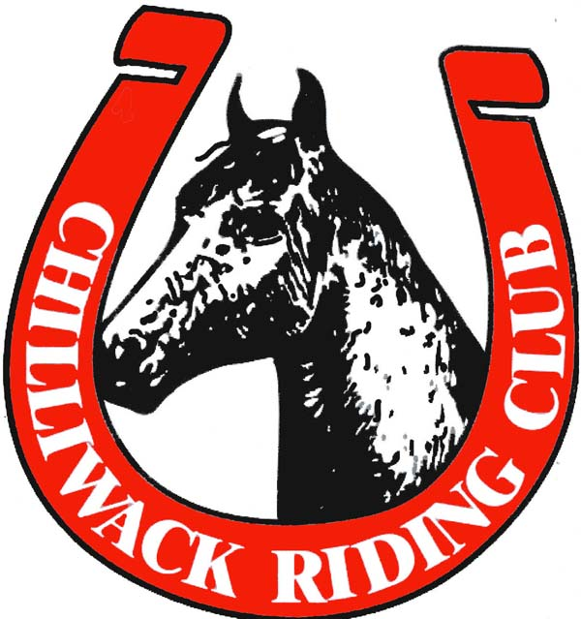

CHILLIWACK RIDING CLUB
2019

HORSE SHOW RULES

1) Manageable stallions may be handled and ridden by adults aged 19 and older only.
2) All classes in point horse shows will count towards High Point daily awards. Only equitation and pleasure classes will count towards Year End Awards at point shows.
3) Show point system:

# Riders | First | Second | Third | Fourth | Fifth | Sixth
6+ | 7 | 5 | 4 | 3 | 2 | 1
5 | 6 | 4 | 3 | 2 | 1 | -
4 | 5 | 3 | 2 | 1 | - | -
3 | 4 | 2 | 1 | - | - | -
2 | 3 | 1 | - | - | - | -
1 | 1 | - | - | - | - | -

4) Gate holds are available upon request. No entry into the arena after the gate is closed.
5) Entrants in Walk/Trot classes are not permitted to canter in the warm-up arena.
6) Age divisions (rider age as of January 1st):

Walk/Trot A | 12 and under
Walk/Trot B | 13 +
Green | 5 or fewer horse shows in 3 years
Junior | 13 and under
Youth | 14-17
Senior | 18+
Leadline | No age limit

7) Required English Attire and Tack
Attire: Helmet or bowler, suitable jacket or sweater, boots with a heel, breeches
Tack: English saddle of any type. Bridles may be double, Pelham, snaffle, or kimberwick. Breast collars are optional. No martingales, training equipment, boots, or bandages.
8) Required Western Attire and Tack:
Attire: Western hat (for 19+), or helmet. Suitable western shirt with collar or western show slinky shirt, boots with a heel, and jeans or pants. Chaps are optional.
Tack: Western saddle of any type. Bits must have a shank with a leather or chain chinstrap that is at least ½ inch wide for horses six years or older, ridden with one hand. One finger allowed between split reins. When Rommel rein is carried, hand must be 16 inches away from the rein in hand. Bosal and mecate reins, or snaffle with split reins held with two hands in a bridge, allowed for horses five years and under.
9) Chilliwack Riding Club Show Committee reserves the right to combine or split classes.
10) No cross entry with Walk/Trot and Green division.
11) First place Year End High Point for Green and Walk/Trot divisions must move to appropriate division the following year.
12) To qualify for Year End in horse shows, CRC members must compete in at least 60% of point shows and must volunteer for at least 5 CRC functions.
* Rider must obtain 5 volunteer points for each horse on which they are competing to qualify for year end awards
13) The Judge’s decision is final.

Revised: June 2019

